**INDUSTRIAL UNIVERSITY OF HO CHI MINH CITY**

**FACULTY OF INFORMATION TECHNOLOGY**



GRADUATION THESIS

**REPORT - WEEK 02 –**

**PACS AND ORTHANC**

SUPERVISOR: HIEU TRUNG HUYNH, Ph.D.

HO CHI MINH CITY – 01/2018

# table of contents

Page

1. PACS 3

1.1 Introduction 3

1.2 Architecture 3

2. Orthanc 5

2.1 Overview 5

2.2 Configuration 5

# PACS

## Introduction

A **picture archiving and communication system** (PACS) is a medical imaging technology which provides economical storage and convenient access to images from multiple modalities (source machine types). The universal format for PACS image storage and transfer is DICOM.

A PACS consists of four major components: The imaging modalities such as X-ray plain film (PF), computed tomography (CT) and magnetic resonance imaging (MRI), a secured network for the transmission of patient information, workstations for interpreting and reviewing images, and archives for the storage and retrieval of images and reports.

Most PACSs handle images from various medical imaging instruments, including ultrasound (US), magnetic resonance (MR), Nuclear Medicine imaging, positron emission tomography (PET), computed tomography (CT), etc.

PACS has four main uses:

* Hard copy replacement
* Remote access
* Electronic image intergration platform
* Radiology workflow management

## Architecture

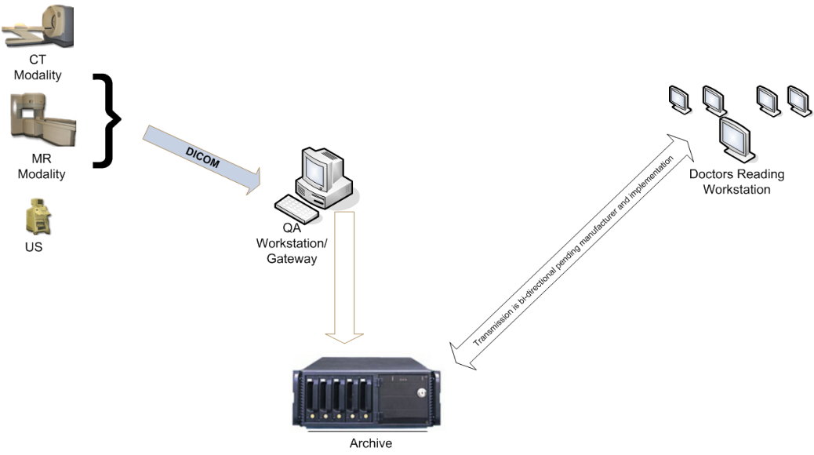

Figure 1.1. PACS workflow diagram

Typically, a PACS consists of a multitude of devices. The first step in typical PACS systems is the modality. Modalities are typically computed tomography (CT), ultrasound, nuclear medicine, positron emission tomography (PET), and magnetic resonance imaging (MRI). Depending on the facility's workflow most modalities send to a quality assurance (QA) workstation or sometimes called a PACS gateway. The QA workstation is a checkpoint to make sure patient demographics are correct as well as other important attributes of a study. If the study information is correct the images are passed to the archive for storage. The central storage device (archive) stores images and in some cases reports, measurements and other information that resides with the images. The next step in the PACS workflow is the reading workstations. The reading workstation is where the radiologist reviews the patient's study and formulates their diagnosis. Normally tied to the reading workstation is a reporting package that assists the radiologist with dictating the final report.

More and more PACS include web-based interfaces to utilize the internet or a Wide Area Network as their means of communication. The clients side software may use ActiveX, JavaScript and/or a Java Applet. As the need for distribution of images and reports becomes more widespread there is a push for PACS systems to support DICOM. Web Access to DICOM Objects (WADO) creates the necessary standard to expose images and reports over the web through truly portable medium.

# Orthanc

## Overview

Orthanc is a free, open-source, lightweight, RESTful, standalone DICOM server enabling secure and easy exchange of information between departments, physicians and hospitals. The fully self-contained mini PACS system can be downloaded and run immediately. Orthanc has a REST API, a means of connecting with the image server by using standard web protocols and tools. This allows Orthanc to be accessed through Web connections from anywhere, and without regard to the platform or language used in the originating program.

Orthanc also features a Software development kit (SDK), enabling the development of plugins that extends the core system. For instance, as official plugins, Orthanc can be extended with a Web viewer of medical images, with support of the DICOMweb standard and with PostgreSQL as the database back-end instead of SQLite.

## Configuration

Orthanc can act both as a DICOM client and as a DICOM server, depending on the parameters in its configuration file. Configuring the DICOM server of Orthanc by following options:

* DicomServerEnabled must be set to true.
* DicomAet must be set to the *application entity title* (AET) that is reserved to Orthanc.
* DicomPort specifies the TCP port of the DICOM server.

To configure Orthanc as a DICOM client, we must list the remote DICOM servers that are known to Orthanc into the DicomModalities option. For each remote server, we must specify in the following order:

* An user-friendly, symbolic name for the server that will be displayed by Orthanc Explorer (possibly its AET).
* The AET of the remote server.
* Its IP address or its hostname.
* Its DICOM port (most probably 104, or 4242 if the remote server is another instance of Orthanc).